VAULTVIEW
BANKING TRANSACTION MANAGEMENT AND ANALYSIS SYSTEM

PROJECT DOCUMENTATION

Submitted by: B. Heythishwi
Department: Computer Science and Engineering (CSE)
Institution: Mohan Babu University
Project Guide: Mohamad Valli

1. Abstract:
Vault View is a Banking Transaction Management and Analysis System developed as an educational project. The system demonstrates how customer information, bank accounts, and financial transactions can be managed and analysed using modern software technologies.
The application provides features such as user authentication, account management, deposits, withdrawals, money transfers, transaction history, financial reports, and data visualisation.
Python and Flask are used for backend development, MySQL is used for database management, and Pandas and NumPy are used for analysing transaction data. The frontend provides an interactive interface through which users can access the system.
The main objective of Vault View is to demonstrate the integration of frontend development, backend programming, database management, and data analysis in one application.
Note: Vault View is an educational simulation that uses synthetic data. It is not a real banking platform.

2. Introduction:
Banking transaction management involves maintaining customer information, managing accounts, recording financial transactions, and analysing account activities.
Managing these operations manually can be time-consuming and difficult to monitor. A computer-based system can simplify these processes by organising information and generating useful reports.
VaultView was developed to demonstrate these operations through a web-based application. It combines database management, transaction processing, and data analysis to provide a structured banking simulation.

3. Problem Statement:
Managing customer accounts and financial transactions requires accurate data storage, proper validation, and organised reporting.
Manual methods may create difficulties in maintaining transaction records, calculating summaries, and identifying transactions that require additional review.
Therefore, Vault View was developed as an educational application to demonstrate how these activities can be handled using Python, Flask, MySQL, and data analysis libraries.

4. Objectives:
The main objectives of the project are:
- To develop a web-based banking transaction management system.
- To implement Admin and User authentication.
- To maintain customer and account information.
- To record deposits, withdrawals, and money transfers.
- To maintain transaction history.
- To generate account-wise and monthly transaction summaries.
- To analyse transaction data using Pandas and NumPy.
- To display transaction information through charts and reports.
- To implement input validation and basic access control.
- To integrate and test all system modules.

5. Scope of the Project:
The project focuses on educational banking operations using synthetic data.
The system includes:
- User registration and login.
- Admin and User roles.
- Customer and account management.
- Deposit and withdrawal operations.
- Money transfer functionality.
- Transaction history.
- Dashboard statistics.
- Monthly financial reports.
- Account-wise summaries.
- Transaction review flags.
- Data visualisation.
The application does not connect to real banking networks or process actual financial transactions.

6. Technologies Used:
Technology | Purpose
HTML | Structure of web pages
CSS | Styling and page layout
JavaScript | Frontend interaction
Python | Application programming
Flask | Backend web framework
MySQL | Database management
Pandas | Data analysis and summaries
NumPy | Numerical calculations
Chart.js | Interactive dashboard charts
7. System Architecture:
Vault View follows a layered application structure.
7.1 Frontend Layer
The frontend is developed using HTML, CSS, and JavaScript. It provides login pages, dashboards, transaction forms, and report displays.
7.2 Backend Layer
Python and Flask handle application logic, authentication, transaction operations, and communication between the frontend and database.
7.3 Database Layer
MySQL stores user details, customer information, account records, and transaction history.
7.4 Data Analysis Layer
Pandas and NumPy are used to process transaction records and calculate summaries and trends.
7.5 Visualisation Layer
Charts and dashboard components present transaction summaries and other analytical information.

8. Database Design:
The project uses a MySQL database named banking_analysis.
The main tables are:
8.1 app_users
Stores login information for Admin and User accounts.
Column | Description
user_id | Unique user identifier
username | Login username
password_hash | Hashed password
role | ADMIN or USER
8.2 customers
Stores customer information and connects customers to login accounts.
Column | Description
customer_id | Unique customer identifier
display_name | Customer display name
created_at | Record creation time
user_id | Reference to app_users
8.3 accounts
Stores account information.
Column | Description
account_id | Unique account identifier
customer_id | Reference to customers
account_type | SAVINGS or CURRENT
created_at | Account creation time
8.4 transactions
Stores transaction records.
Column | Description
transaction_id | Unique transaction identifier
account_id | Reference to accounts
transaction_date | Date and time of transaction
transaction_type | DEPOSIT or WITHDRAWAL
amount | Transaction amount
description | Optional transaction description
Database Relationships
- Each customer can be associated with a login account.
- A customer can have multiple bank accounts.
- Each account can have multiple transaction records.
- Foreign keys maintain relationships between the tables.

9. System Modules:
9.1 Authentication Module
Provides login functionality and distinguishes between Admin and normal User accounts.
Passwords are stored as password hashes rather than plain text.
9.2 Customer and Account Management Module
Maintains customer information and associated account details.
9.3 Transaction Management Module
Handles deposit, withdrawal, and money transfer operations with input validation.
9.4 Transaction History Module
Displays previously recorded transactions for the relevant account.
9.5 Dashboard Module
Displays important information such as total accounts, transactions, deposits, and withdrawals.
9.6 Reports Module
Generates financial summaries, monthly reports, and account-wise reports.
9.7 Data Analysis Module
Uses Pandas and NumPy to process transaction records and calculate analytical results.
9.8 Transaction Review Module
Identifies transactions that cross a configured review threshold. These flags indicate transactions for review and do not establish fraudulent activity.

10. Admin and User Roles:
Vault View uses role-based access control.
Admin Role:
- Accesses administrative functionality.
- Manages system-level operations.
- Views overall system information and reports.
- Can access protected administrative routes.
User Role:
- Logs in using registered credentials.
- Views associated account information.
- Performs permitted transaction operations.
- Views relevant transaction history.
New user registration should assign the USER role by default. Admin accounts are created separately through an authorised process.

11. Implementation:
The application is implemented using Python and Flask for backend operations and MySQL for persistent data storage.
The frontend communicates with the backend through application routes and API endpoints.
The backend validates transaction information before storing records in the database.
Pandas and NumPy support transaction calculations and analytical operations. Dashboard charts present the results in an understandable format.

12. Integration and Testing:
Integration and testing ensure that the different modules work together correctly.
The main testing activities include:
- Checking login functionality.
- Testing Admin and User access.
- Verifying account information.
- Testing deposit operations.
- Testing withdrawal operations.
- Checking money transfer functionality.
- Verifying transaction history.
- Checking report calculations.
- Testing input validation.
- Checking database communication.
- Verifying error handling.
Testing helps identify integration problems and ensures that the system produces consistent results.

13. Team Contributions:
The project was developed collaboratively by five team members.
Member | Responsibility | Contribution
Member 1 | Database Management | Designed MySQL tables, relationships, primary keys, foreign keys, and constraints.
Member 2 | Backend Development | Implemented Python database operations and transaction processing.
Member 3 | Data Analysis | Used Pandas and NumPy to calculate summaries and transaction trends.
Member 4 | Frontend and Visualisation | Developed the user interface and visual representations of transaction data.
B. Heythishwi (Member 5) | Integration and Testing | Integrated frontend, backend, database, and analysis modules; tested functionality, validation, data flow, and error handling.
14. My Individual Contribution – B. Heythishwi
My assigned responsibility in the project was Integration and Testing.
My contributions included:
- Connecting the frontend with the Flask backend.
- Integrating backend operations with the MySQL database.
- Connecting transaction processing with the data analysis components.
- Testing account viewing and transaction operations.
- Verifying deposit and withdrawal functionality.
- Testing transaction history and financial reports.
- Checking input validation and error handling.
- Identifying integration issues and verifying their corrections.
My work helped bring the individual project modules together into a functioning application.

15. Results and Screenshots:

The Vault View application was successfully developed with different pages for user authentication, account management, transaction processing, and financial analysis. The following screenshots demonstrate the major functionalities of the system.

15.1 Login Page
The login page provides a secure entry point to the VaultView application. Users can enter their username and password to access the system. Based on the assigned role, the application provides access to the appropriate dashboard for Admin or User.
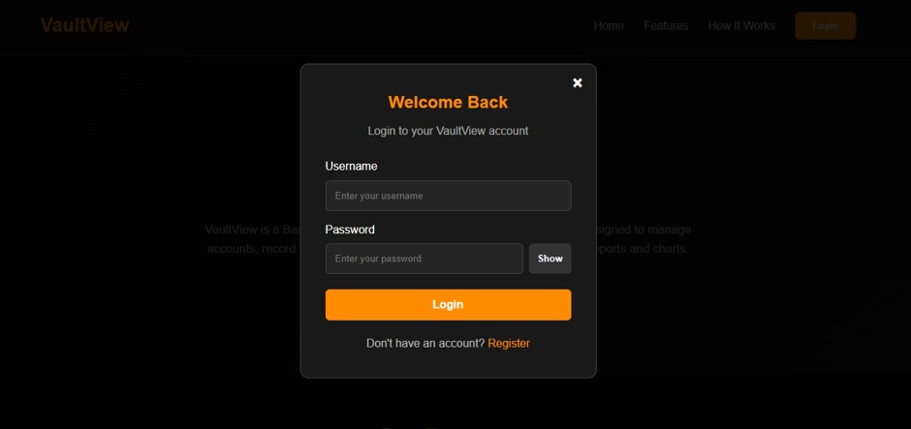
Fig 15.1.1: Login page

15.2 Registration Page
The Registration Page allows new users to create an account in the VaultView application by providing the required details, such as username and password. The system validates the entered information and securely stores the password in hashed format. After successful registration, the user can log in and access the application using their registered credentials. By default, newly registered accounts are assigned the USER role.

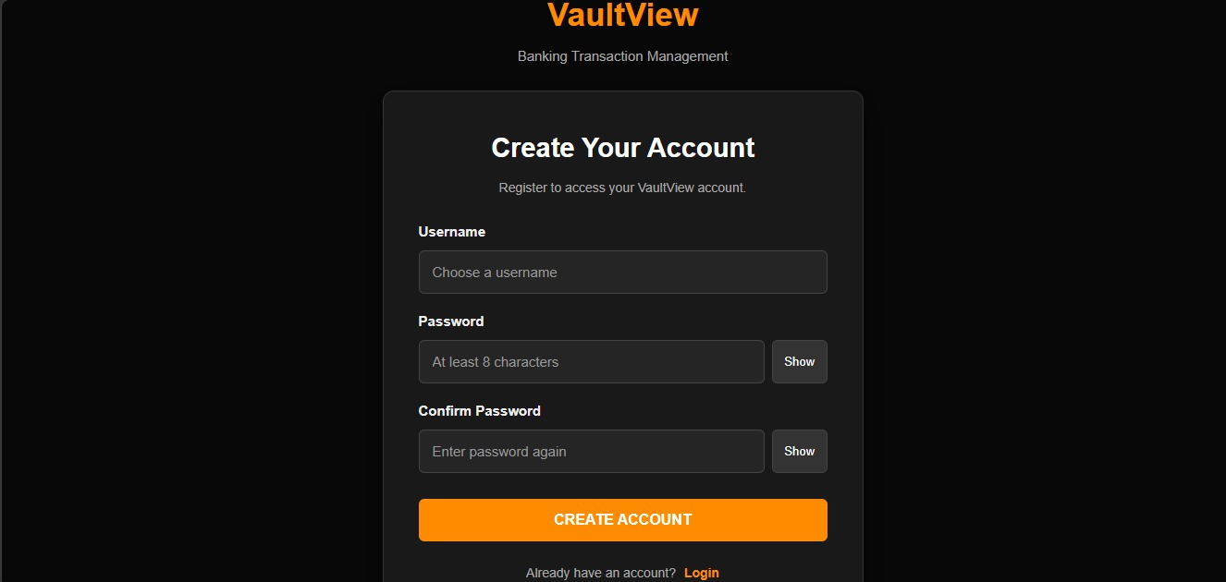
Fig 15.2.1: Registration page

15.3 User Dashboard
The User Dashboard provides an overview of the user's banking activities. It displays relevant account information and transaction details, allowing users to access their banking operations through a simple interface.

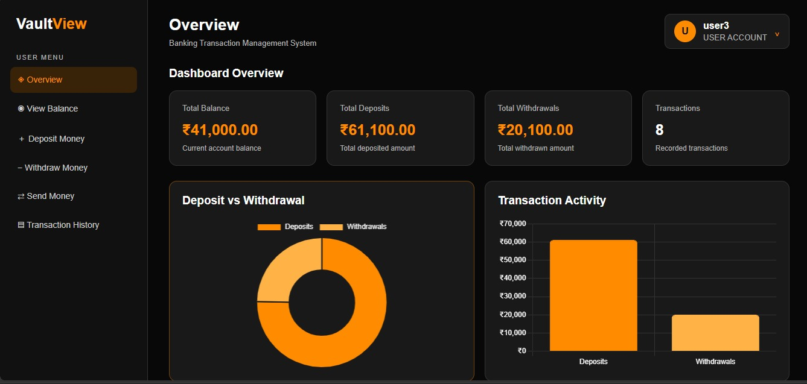
Fig 15.3.1: User Dashboard - overview

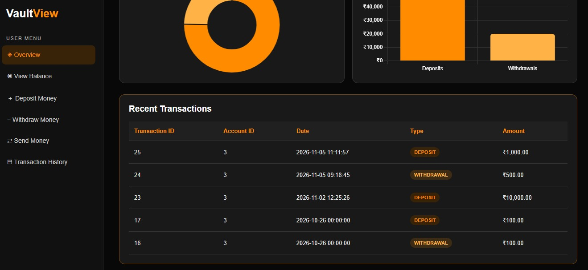
Fig 15.3.2: Dashboard- Recent transcations

15.4 Admin Dashboard
The Admin Dashboard provides administrative access to the system. It allows the administrator to view overall system information and access management features, reports, and transaction-related details.

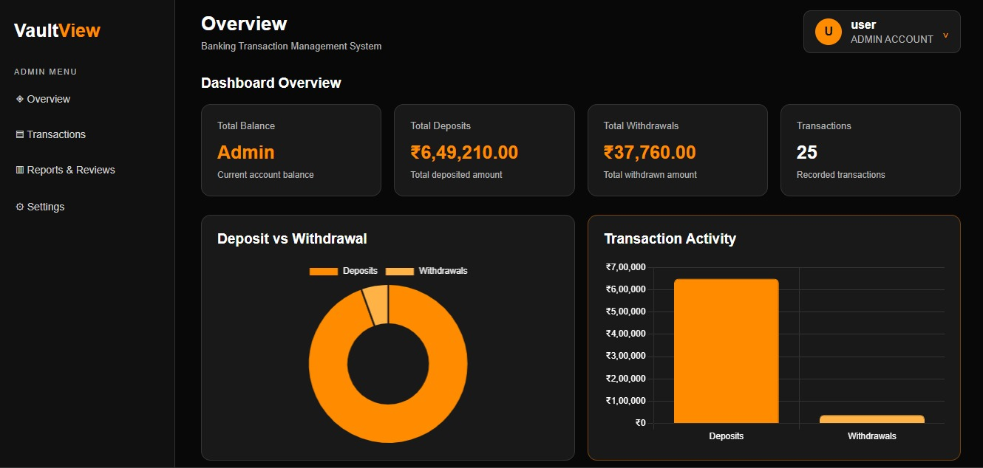
Fig 15.4.1: Admin Dashboard-overview

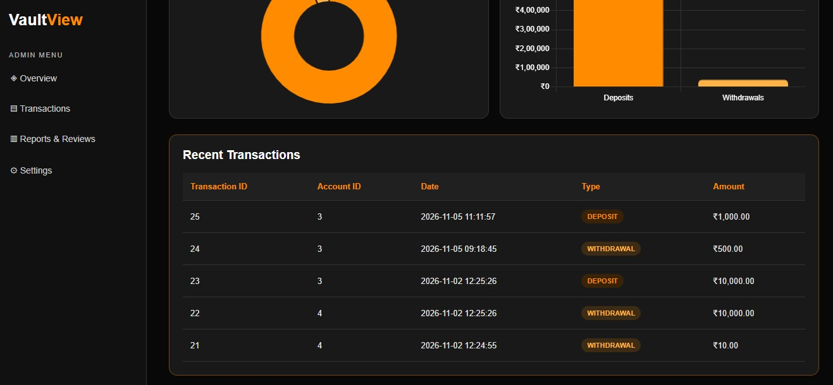
Fig 15.4.2: Dashboard-Recent Transactions

15.5 Account Management Page
The Account Management page displays the available customer account information, including account IDs, customer details, and account types. It helps organise and manage account-related records.
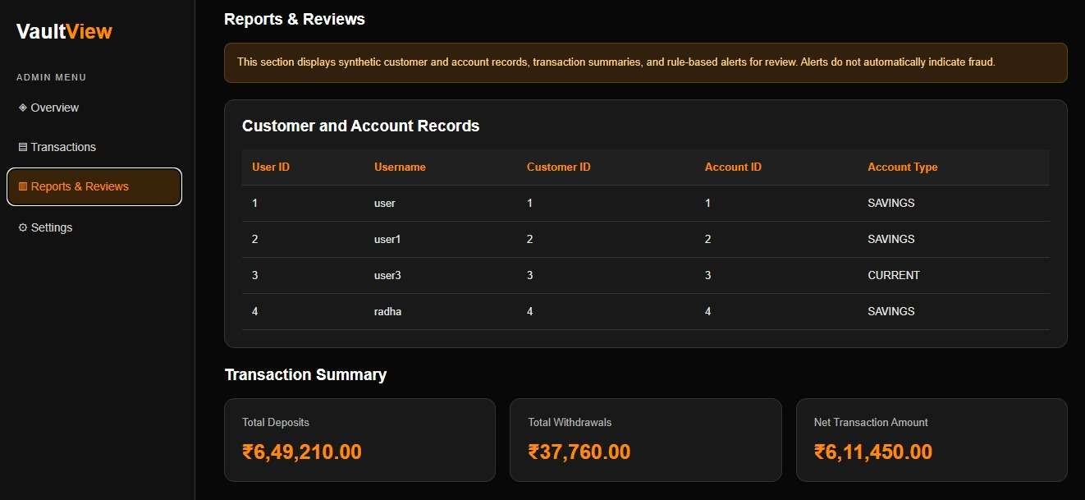
Fig 15.5: Account Management Page

15.6 Deposit and Withdrawal Page
This page allows users to perform deposit and withdrawal operations by entering the required account information and transaction amount. The system validates the input before processing the transaction.

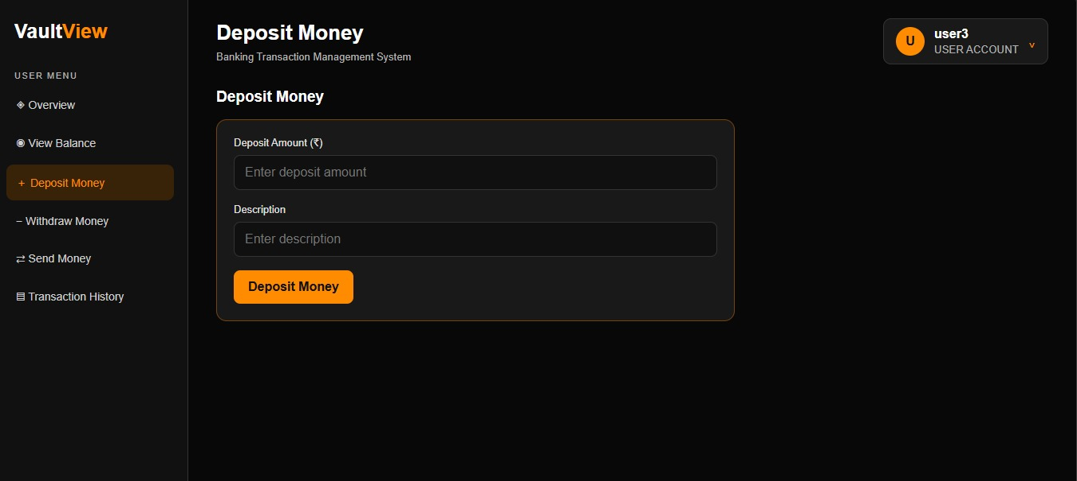
Fig 15.6.1: Deposit Page

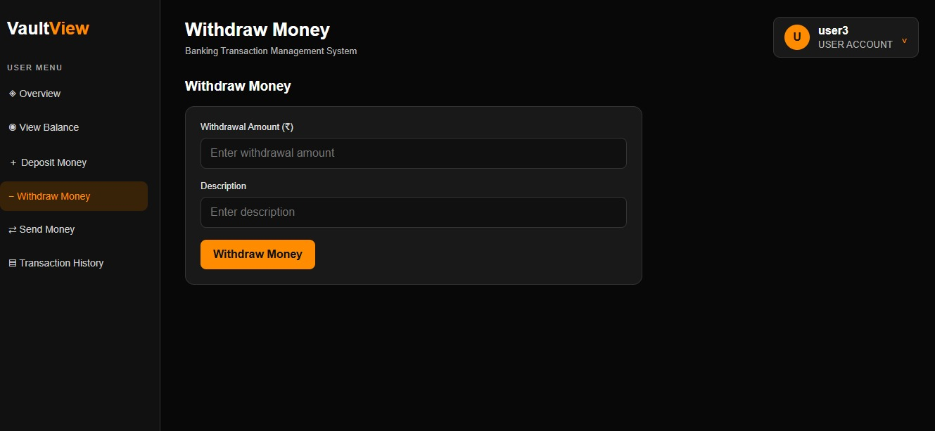
Fig 15.6.2: Withdrawal Page

15.7 Transaction History Page
The Transaction History page displays previously recorded transactions. It provides details such as transaction ID, account ID, transaction date, transaction type, amount, and description.

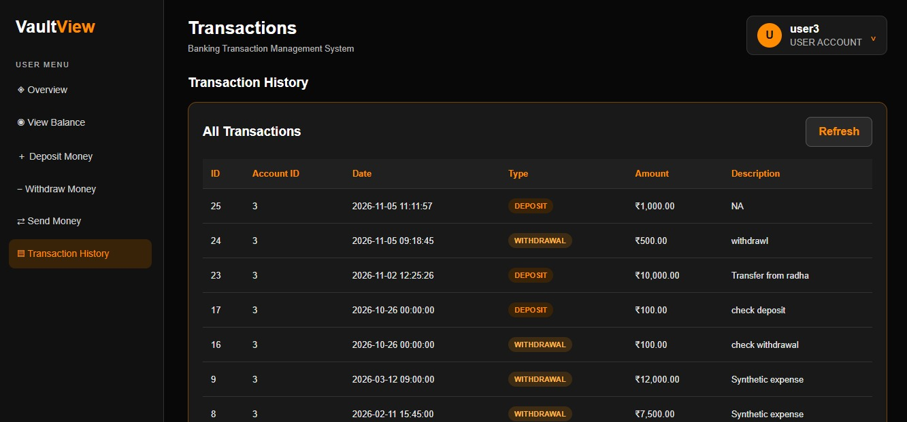
Fig: 15.7.1: user-Transaction history page

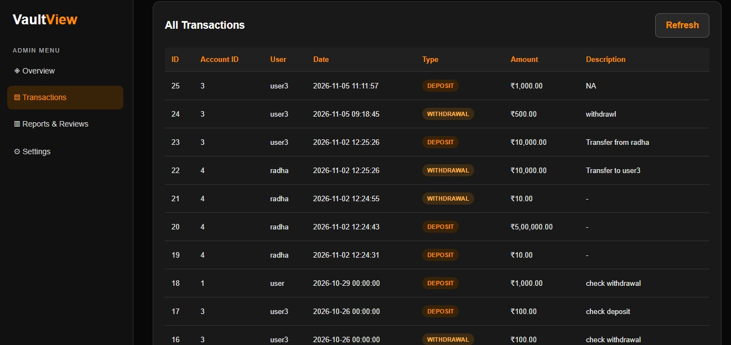
Fig 15.7.2: Admin- Transaction history page

15.8 Monthly Reports Page
The Monthly Reports page presents deposit and withdrawal summaries for different months. It helps users understand transaction activity over a selected period.

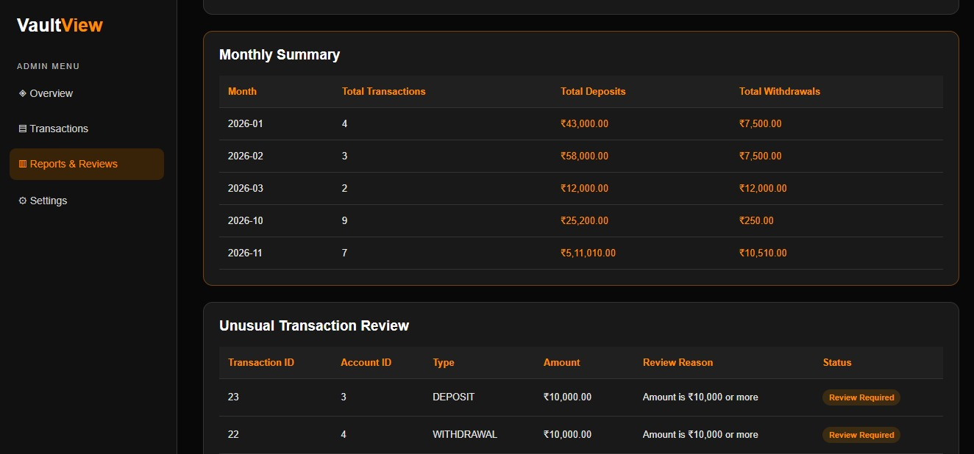
Fig 15.8: Monthly Report page

15.9 Data Visualisation Page
The Data Visualisation page presents transaction information through charts and graphical representations. It makes it easier to understand deposit and withdrawal patterns and compare transaction activities.
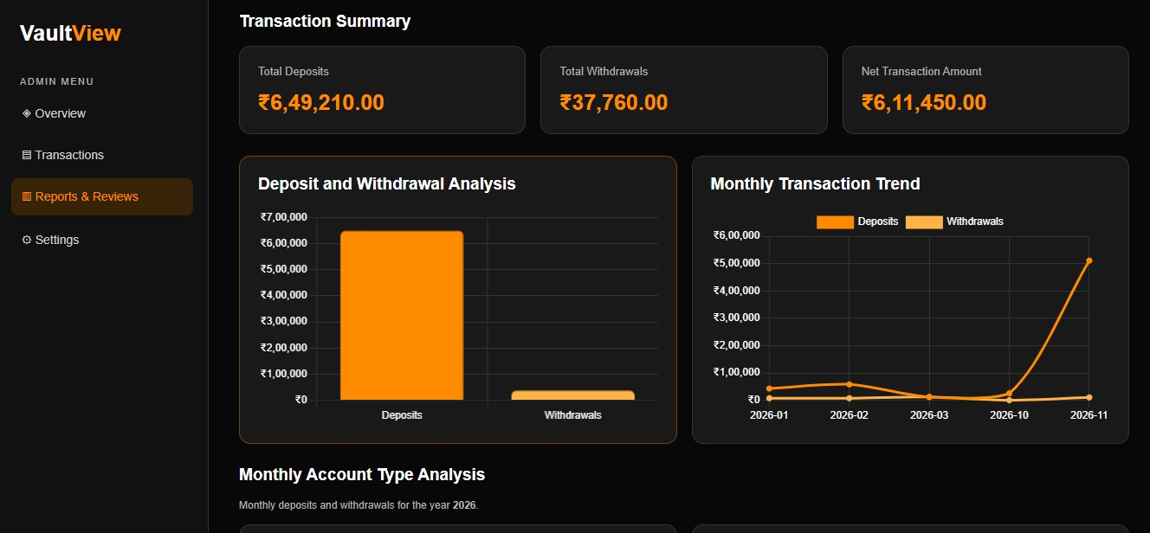
Fig:15.9.1: Overall Visualisation

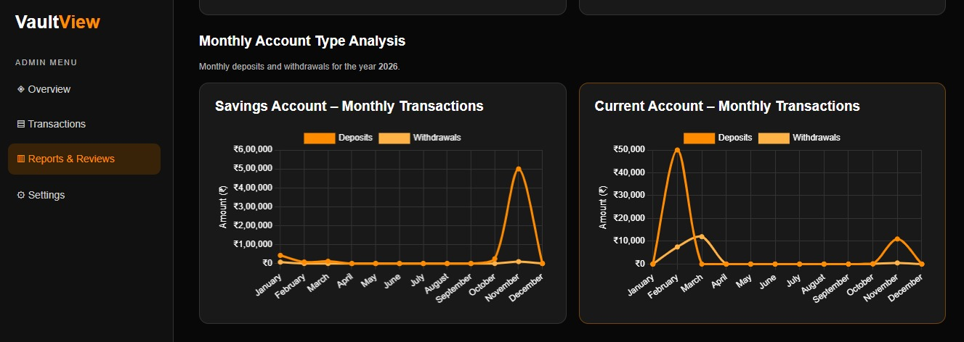
Fig:15.9.2: Account Type Visualisation

15.10 Account-wise Summary Page
The Account-wise Summary page displays transaction statistics for individual accounts. It includes transaction counts, total deposits, total withdrawals, and calculated balances.
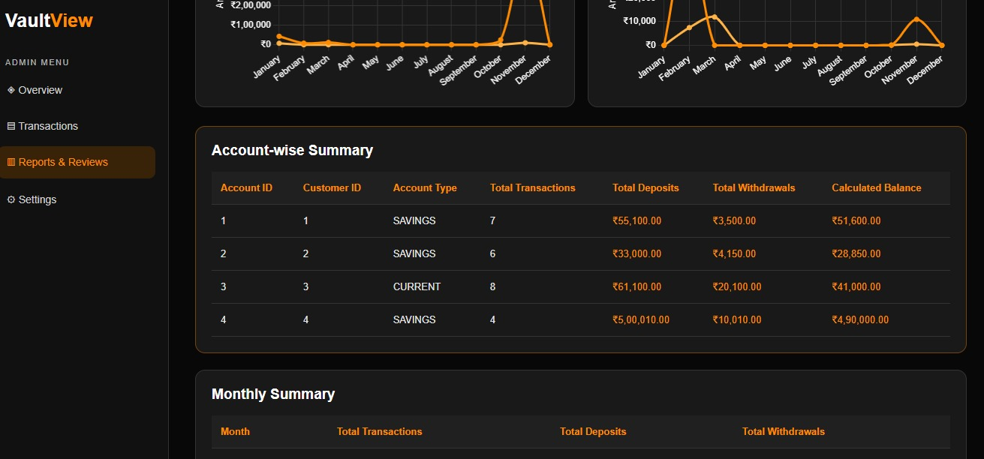
Fig 15.10: Account wise Summary page

16. Advantages:
- Organised storage of customer and account information.
- Easy access to transaction history.
- Automated transaction summaries.
- Role-based access control.
- Improved understanding of database relationships.
- Visual representation of transaction information.
- Practical integration of web development and data analysis.

17. Limitations:
- The system uses synthetic educational data.
- It is not connected to real banking services.
- It does not process actual financial payments.
- Transaction review flags are based on configured rules.
- It is not designed for production banking environments.

18. Future Enhancements:
Possible future improvements include:
- Enhanced dashboard visualisations.
- More detailed financial reports.
- Additional transaction analysis techniques.
- Improved user management features.
- More comprehensive testing.
- Deployment for controlled demonstration purposes.

19. Conclusion:
Vault View demonstrates the development of a banking transaction management and analysis application using Python, Flask, MySQL, Pandas, and NumPy.
The project combines frontend development, backend programming, database management, authentication, transaction processing, and data analysis.
Through this project, the team gained practical experience in software development, database integration, teamwork, and testing.
The completed application provides an educational demonstration of how transaction records can be managed and analysed in a structured environment.

20. Acknowledgement:
We sincerely thank our project guide, Mohamad Valli, for guidance and support throughout the development of this project.
We also express our gratitude to Mohan Babu University, Department of Computer Science and Engineering, for providing the opportunity to work on this project.
Finally, we thank all team members for their cooperation and contributions towards completing Vault View.

21. References:
- Python Documentation – https://docs.python.org/
- Flask Documentation – https://flask.palletsprojects.com/
- MySQL Documentation – https://dev.mysql.com/doc/
- Pandas Documentation – https://pandas.pydata.org/docs/
- NumPy Documentation – https://numpy.org/doc/
- Chart.js Documentation – https://www.chartjs.org/docs/

